**FYP II Final Report**



**Drone Navigation using Brain-Computer Interface (BCI)**

**Project Code : 19S-16**

**Project Supervisor : Dr. Ahsanullah Abro**

**Project Co-Supervisor : Dr. Ahmed Ali Shah**

**Project Manager : M Raheal Safdar**

**Project Team : Naneeta, Madiha**

**Submission Date : 15 - January - 2023**

**_________________________________**

**Signature of the Project Supervisor**

**Document Information:**

| Category | Information |
| --- | --- |
| Customer | Sukkur IBA University |
| Project Title | Drone Navigation using Brain-Computer Interface (BCI) |
| Document | FYP II Final Report |
| Document Version | 1.0 |
| Identifier | 19S-16 Final Report |
| Status | Final |
| Author(s) | M Raheal Safdar, Naneeta, Madiha |
| Approver(s) |  |
| Issue Date |  |
| Distribution | 1. Advisor/Supervisor 2. Project Manager |

**Definition of Terms, Acronyms and Abbreviations:**

| Term | Description |
| --- | --- |
| BCI | Brain-Computer Interfaces |
| ML | Machine Learning |
| EEG | Electroencephalography |
| CNN | Convolutional Neural Network |
| PSD | Power Spectral Density |
| Tello EDU | A brand of drone |
| Arduino | A brand of microcontroller |
| Ag/AgCl | Silver-Silver Chloride |
| SSVEP | Steady-State Visual Evoked Potential |

**DEDICATION**

This report is a tribute to our cherished parents and teachers, who have served as a continual source of motivation and have provided us with financial, moral, and spiritual support when we were on the verge of giving up. Especially, to Late Prof. Nisar Ahmed Siddiqui, who provided us the opportunity to study at such an esteemed institution.

**ACKNOWLEDGEMENTS**

We sincerely thank the Almighty God for providing us with the knowledge we needed to plan and carry out this project. Never was there a shortage or a need. He took charge of anything that could have gotten in the way of this development and supported us through the toughest times.

We respect the Late Professor Nisar Ahmed Siddiqui, the Vice Chancellor of the great institution, because he has pursued God's guidance and creation and nurtured the vision of Sukkur IBA University, a diverse and a world-class institution where we were educated to compete and succeed in the entire world. We cannot disregard the head of the department of computer science and other faculty members who pay attention to and behave in a way that benefits students. Nevertheless, our teachers encouraged and aided us in achieving our objective.

**Table of Content**

**PROJECT ABSTRACT** 7

**1)** **RELEVANT BACKGROUND** 8

**1.1)** **Brain Computer Interfaces (BCI)** 8

**1.1.1)** **Types of BCIs** 8

**1.1.2)** **Applications of BCI** 9

**1.1.3)** **Previous Work** 10

**1.2)** **How BCI Works** 12

**1.2.1)** **Brain Structure** 13

**1.2.2)** **Electroencephalography (EEG) Signals** 14

**1.2.3)** **Artifacts** 18

**1.2.4)** **EEG Signal Pre-Processing** 19

**1.2.5)** **Feature Extraction** 20

**1.2.6)** **Different Paradigms of BCIs** 20

**1.3)** **Drone Navigation** 21

**1.3.1)** **Importance of Drone Navigation** 21

**1.3.2)** **Applications of Drone Navigation** 22

**1.3.3)** **Traditional Drone Navigation Methods** 22

**1.3.4)** **Limitations and Challenges of Traditional Drone Navigation Methods** 23

**1.4)** **Problem Identification** 24

**2)** **PROPOSED APPROACH** 24

**2.1)** **Dataset Discussion** 24

**2.1.1)** **Motor Imagery in EEG Signals** 24

**2.1.2)** **EEG Signal Acquisition** 25

**2.1.3)** **OpenBCI Headset** 26

**2.1.4)** **USB Dongle** 26

**2.1.5)** **OpenBCI GUI** 27

**2.2)** **Data Preprocessing** 28

**2.3)** **Model Training and Fine Tuning** 29

**2.4)** **Online Operation** 31

**2.5)** **Drone Navigation on Simulator** 32

**3)** **EVALUATION TESTBED** 33

**4)** **RESULTS AND DISCUSSION** 33

**5)** **LIMITATIONS AND FUTURE WORK** 34

**5.1)** **Limitations** 34

**5.2)** **Future Work** 34

**6)** **REASONS FOR FAILURE *(If Any)*** 34

**7)** **PROJECT MANAGEMENT UTILITY** 34

**REFERENCES** 36

**List of Figures**

**Figure 1:** A typical BCI System 12

**Figure 2:** Brain Structure 13

**Figure 3:** Different frequency bands of an EEG signal 16

**Figure 4:** 10-20 positioning system: the electrodes are separated between distances of 10 and 20 percent of the dimensions of the head. 18

**Figure 5:** A block diagram of signal processing stage in a BCI 19

**Figure 6:** OpenBCI Ultracortex Mark IV headset with Cyton Board 25

**Figure 7:** USB Dongle 26

**Figure 8:** OpenBCI GUI 27

**Figure 9:** Raw EEG Data 28

**Figure 10:** EEG data after Standardization 29

**Figure 11:** EEGNet Architecture 29

**Figure 12:** Feature Extraction Layer 30

**Figure 13:** AirSim Drone Simulator 32

**Figure 14:** Confusion Matrix 33

**List of Tables**

**Table 1:** Brainwave frequencies with their characteristics 17

# **PROJECT ABSTRACT**

The Brain Computer Interfaces (BCIs) have been widely studied as a promising area of research in the field of Human-Computer Interaction (HCI). The optimal location for BCIs is at the intersection of human and machine adaptability. BCI systems translate brain signals into digital information that can be processed by a computer and used to control devices or execute tasks. This project aims to develop a BCI system that uses electroencephalogram (EEG) to detect and translate a user's neural actions and activities into navigational cues for controlling a drone in physical space. The system will allow users to control a drone using six control commands: up, down, left, right, forward and backward. The EEG headset will be placed on the user's scalp to detect and record the electrical activity of the brain's surface layer and translate those signals into commands for controlling the drone. This work is focused on developing a BCI system to aid individuals in exploring the world around them with the help of a computer and their brain signals. This work can be utilized in future by extending it to control drones for multiple purposes like weight lifting.

# **RELEVANT BACKGROUND**

## **Brain Computer Interfaces (BCI)**

Brain-Computer Interface (BCI) technology refers to the direct communication between the human brain and a computer. BCI technology utilizes brain signals, such as electroencephalography (EEG) or magnetoencephalography (MEG), to enable individuals to control computers, devices, or machines directly through their brain. BCI technology has the potential to revolutionize the way we interact with technology, allowing for more natural and intuitive control. BCI systems can range from simple systems that allow individuals to control a cursor on a screen, to more advanced systems that enable individuals to control prosthetic limbs or operate complex machines. In recent years, BCI technology has been applied in a range of fields, including medicine, gaming, and human-computer interaction. The development of BCI technology is driven by the desire to create new and more efficient ways of communicating with computers, as well as the desire to help individuals with disabilities or other impairments regain their independence.

BCI technology is still in its early stages of development and there are still many challenges that need to be overcome, such as improving the accuracy and reliability of BCI systems, reducing the complexity and cost of BCI systems, and addressing the ethical and social implications of BCI technology. Nevertheless, the potential benefits of BCI technology are enormous and its development is likely to have a major impact on a range of industries and applications in the future.

### **Types of BCIs**

Brain-computer interfaces (BCIs) can be broadly categorized into two types: non-invasive and invasive. Non-invasive BCIs use techniques such as electroencephalography (EEG) and functional magnetic resonance imaging (fMRI) to measure brain activity from the surface of the scalp. These methods are non-invasive and relatively safe, but have limited accuracy and resolution [1]. We are using this type of BCI in our peoject.

Invasive BCIs, on the other hand, involve the implantation of electrodes directly into the brain. This method provides a more direct measurement of neural activity and has higher accuracy and resolution. However, it is invasive and carries a higher risk of potential side effects such as infection, bleeding, and other medical complications [2].

### **Applications of BCI**

Brain-Computer Interface (BCI) technology has a wide range of potential applications, including:

* Medical Applications: BCI technology has the potential to revolutionize the field of medicine. BCI systems can be used to help individuals with disabilities, such as spinal cord injuries or neurodegenerative diseases, regain their independence. For example, BCI systems can be used to control prosthetic limbs, wheelchairs, or other assistive devices. BCI technology can also be used for neuro-feedback, which is a form of therapy that uses real-time feedback to help individuals change their brain activity patterns to overcome conditions such as anxiety, depression, or chronic pain.
* Gaming: BCI technology has the potential to revolutionize the gaming industry by providing a more natural and intuitive way of playing games. BCI systems can be used to control games directly using brain, or they can be used to enhance the gaming experience by measuring the player's emotional state and adjusting the game accordingly.
* Human-Computer Interaction: BCI technology has the potential to revolutionize the way we interact with computers, allowing for more natural and intuitive control. BCI systems can be used to control computers, devices, or machines directly through brain, eliminating the need for traditional input devices such as keyboards, mice, or touchscreens.
* Military Operations: BCI technology has potential applications in military operations, allowing for more efficient and effective communication between soldiers and military equipment. For example, BCI systems can be used to control unmanned aerial vehicles (UAVs), unmanned ground vehicles (UGVs), or other military equipment directly through brain, reducing the time and effort required to operate the equipment.
* Human Augmentation: BCI technology has the potential to augment human abilities, such as enhancing memory, attention, or perception. BCI systems can be used to provide real-time feedback to the user, allowing them to monitor their brain activity and adjust it to achieve better performance.

### **Previous Work**

Studies on various drone control techniques, including the use of brain-computer interfaces, have been done in the drone technology field (BCI). The goal of the earlier research was to comprehend the viability and potential advantages of adopting BCI for drone navigation. The current section expands on this body of knowledge by examining the difficulties and restrictions involved in employing BCI for drone navigation. We will give a summary of the pertinent studies and projects that have been done in this area, emphasizing the major findings and contributions to the field at large. This will serve as a starting point for the debate of our own discoveries and advance knowledge of BCI-based drone navigation in general.

The focus at work [3] was to control the drone using facial expressions and mental commands to guide it in different directions. The EEG headset used to collect the brain signals was the Emotional Insight (5-channel) and the Parrot Mambo Fly drone was used for the experiment. The accuracy of the tests was based on the correctness of mental instructions, which indicates how attentive the person is during the test. Signals from the headset are carried to the computer via Bluetooth, and signals from the computer to the raspberry-pi zero microcontroller are sent with the help of Message Queuing Telemetry Transport (MQTT) protocol, which is also used for communication between the drone and the raspberry-pi zero. Emotiv Cortex and python-3 was used to make the software program. This software allows communication between the computer and the headset.

The EEG headset used to collect brain data was the Emotiv EPOC headset (16 channels), and the quadcopter AR 2.0 drone was used for the experiment in the study [4]. The author recovered facial features such as left/right smile, frown and left/right wink. A tablet-based mobile framework based on the Android OS will be created to convert observed patterns into instructions that can be used to control the quadcopter AR 2.0 drone through any wireless medium. The system design includes a signal processing unit, the Emotiv engine development kit and the Emotiv API.

In the study [5], the approach was a fully independent BCI multiclass system based on the Steady-State Visual Evoked Potential (SSVEP) paradigm that is capable of moving the drone in different directions. The EEG headset used to acquire the signals from brain cells was the Emotiv Neuroheadset (16 channels), and the drone was replaced for the experiment by a feedback loop using LEDs that are controlled by an Arduino board. The BCI system was tested on ten healthy subjects. The data obtained from the EEG headset is sent to a desktop using Bluetooth and a USB adapter. A Python script was created and implemented to acquire and decode the EEG raw data signal. MATLAB was used to perform methods like signal processing, feature extraction and classification.

The study [6] methodology specifies four motor imagery tasks that need to be worked on. The first task is to imagine a movement with the left hand without moving the hands. Task 2 is similar to Task 1, but is done with the right hand. Task 3 asks the subject to imagine movements with the left hand, fingers and elbows. Task 4 is similar to Task 3, but is done with the right hand. For the experiment, an Emotiv Inc. headset was used. EPOC+EEG, which provides 14-lead EEG data, and a Parrot 2 AR drone. For the calculation, a dual dataset is applied to the constructed model. The Python-based algorithm runs on a ground station in continuous duplex communication with the UAV over Wi-Fi.

The inactivity or execution of another movement in which no action is performed is described in the work [7], as well as the blink of the left eye to move in the negative direction of the selected axis, the blink of the right eye to move in the positive direction, the direction of the selected axis, raise your eyebrows to select the axis of movement and idle or perform another movement that does not perform an action. For this experiment, a 16-lead EEG headset was paired with a Parrot Mambo drone. Subjects of both sexes, aged between 18 and 30 years, provided recordings for training classifiers. According to the system, the best performing classifiers are RF (with the data filtered at alpha rate and then scaled between zero and one), and the CNN network. The program to connect the drone to the BCI modules and classifier is written in Python, using PyQT5 for the interface, pyOpenBCI to connect to the BCI modules and pyparrot for the drone connection and commands.

The aim of the study [8] was to develop an innovative Brain Computer Interface (BCI) system that responds to patients' brain activity and sends a signal to the aircraft telling it to fly in different directions like up, down, etc. The Emotiv EPOC helmet (16 wires) was used to collect brain data and a custom quadrotor drone was deployed for the experiment. After just 10 minutes of training, a 52% success rate was achieved by completing a task on time. EEG headset data is transmitted to a laptop via Bluetooth and signals from the laptop to the drone are sent via TCP/IP protocol. A C# software application was created to capture and decode the EEG raw data signal, while two C applications were written. The first software is for the server and resides on the laptop connected Printed Circuit Board (PCB), while the second program is for the client and resides on the drone PCB.

The authors of the article [9] proposed a method in which they trained four different mental tasks, one for each direction of drone control: ascending mental task for takeoff, descending mental task for decreasing altitude, right mental task for the movements of the drone to the right side head and left turn in mental task for left side head movements. The Emotiv Insight headset (7 channels) was used to collect brain signals, while the Parrot Rolling Spider drone was used for the experiment. EEGLAB was used as a programming environment that was used to store, measure, manipulate and to access the EEG data that was gathered through the experiments.

## **How BCI Works**

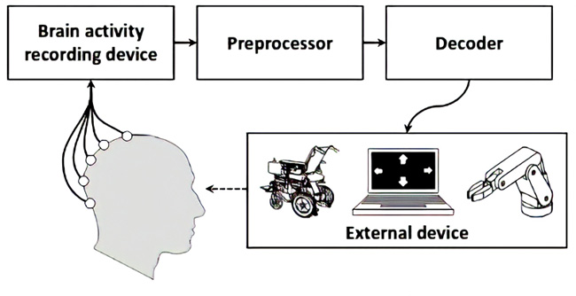The use of Brain computer Interface (BCI) systems offers a way to enhance life quality by providing a different route for communication between the brain and external devices. In order to decipher the user's purpose and subsequently communicate with the outside world, these interface technologies primarily rely on the data stored in brain signals. Electroencephalography (EEG), which involves placing sensors on the user's scalp to monitor neural activity, is the common method for acquiring the neural signal in BCI systems [10]. After being collected, the data is filtered to remove any noise before being digitally processed to find pre-established EEG patterns. In order to send commands to a target application, the identified patterns can subsequently be translated into commands as shown in Figure 1.

**Figure 1:** A typical BCI System

The absence of comprehensive reports about the construction of a BCI system, from EEG signal acquisition through application control, is another significant hurdle that BCI systems developers commonly encounter. In general, research groups tend to focus on modular parts of the system, such as filtering or classification techniques [11] [12], without adequately addressing the links between these submodules. In particular, topics like converting the results of classification algorithms into useful application commands are frequently left out in the literature. As a result, the full implementation faces many difficulties, which suppresses the fundamental benefit of BCI systems, the final control of an application.

### **Brain Structure**

To understand the mechanisms and outputs of the brain while creating a Brain Computer Interface system, a basic understanding of the brain's structure and physiology is necessary. This section aims to provide a comprehensive overview of the various areas and components of the human brain, which are commonly studied in BCI applications, and the dynamics and structure of the brain that are relevant to BCI. According to Figure 2 , the cortex, which is found at the top of the brain, is necessary for BCI systems [13].

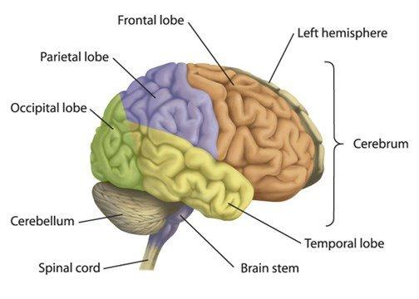

**Figure 2:** Brain Structure

The layout of brain regions is depicted in Figure 2, taken from [14]. The brain's structure is divided into two symmetrical hemispheres by a longitudinal fissure (left and right). Cortex is a thick layer of gray matter that sits on top of each hemisphere. The brain stem, thalamus, and basal ganglia are examples of subcortical regions, which are located below the cortex layer. The frontal (orange), parietal (purple), occipital (green), temporal (yellow), and insula are the five main lobes that make up the cortex (not shown in the picture). The cortex's microscopic ridges (sulci) and grooves (gyri) play a major role in defining these sub-regions [14].

For BCI systems, the brain cortex is crucial since it is connected to many different neurological responses and processes. For instance, processing of auditory information is tied to the temporal lobe, but processing of somatosensory information is related to the parietal lobe. The Primary Motor Cortex (M1) is a part of the cortex that BCI implementations frequently examine because of its close connection to motor functions [2] [15].

The cortex's location at the top of the brain is yet another crucial aspect of this structure. Because of this, signals produced there are less attenuated by the organic structures of the human skull and are therefore simpler to acquire using non-invasive techniques. Through sensors positioned on the surface of the head, this feature enables the monitoring of cortical signals. Electroencephalography is the name of this non-invasive process, which will be described in more detail in the following section [2] [13].

### **Electroencephalography (EEG) Signals**

Millions of neurons make up the human brain, and these neurons play a crucial part in regulating how the body responds to internal and external motor and sensory events. Between the human body and brain, these neurons will serve as information transporters. Analyzing brain signals or images can help one understand the cognitive behavior of the brain. Human behavior can be represented in terms of motor and sensory states, such as clenching of the hands, lip movement, memory, and attention. These states are connected to a certain signal frequency, which aids in understanding the functionality of the complicated activity of the brain. The effective modality of EEG makes it possible to collect brain signals that are related to different states from the surface of the scalp. As illustrated in Figure 3, the EEG signals are separated into frequency bands in the frequency domain that correspond to different types of brain responses. Most commonly, the following ranges and designations [2] [16] [1] are used to categorize the frequency spectrum of EEG signals:

* Delta (0.1 - 4 Hz): Delta waves have the largest amplitude and are the slowest brain waves. They are associated with the gray matter of the brain and are predominantly present during stages 3 and 4 of sleep. This type of brain wave activity is normal for infants and is rarely observed in experienced meditators. On the other hand, delta waves are considered abnormal in adults who are awake and can trigger the release of growth hormone [1, 2, 16].
* Theta (4 - 8 Hz): The Theta waves have a frequency range of 4 to 8 Hz and are linked to subconscious activity. These brain waves are seen during deep relaxation and meditation and play a role in spiritual research by inducing extrasensory abilities through meditation. Theta activity level can also be used by psychics to gain information. Although it is considered abnormal in adults, it is normal for children under 13 years old. Theta waves stimulate the production of hormones that promote relaxation, relieve pain, and improve memory and learning, such as human growth hormone, serotonin, and cortical hormone [1, 2, 16].
* Alpha (8 - 13 Hz): Alpha waves are common in individuals of all ages, particularly in adults who are awake but relaxed with closed eyes. They are present on both sides of the head, with slightly higher amplitude on the non-dominant side and are recorded from the occipital and parietal regions of the brain. Alpha waves are associated with the white matter of the brain and serve as a connection between the conscious and subconscious mind. They stimulate the production of serotonin, a chemical that promotes relaxation and reduces pain. Abnormal Alpha activity is seen in alpha coma, which is caused by hypoxic ischemic encephalopathy and damage to the pons [1, 2, 16].
* Beta (13 - 30 Hz): Beta waves are associated with behavior and actions, and are linked to our senses of sight, touch, hearing, smell, and taste. They are typically present in both frontal and parietal lobes. Beta waves stimulate the production of Cortisol, a hormone that speeds up aging in the brain and influences learning and memory. They occur during conscious activities such as speaking, problem-solving, judgment, and decision making. Beta waves are found in the cortex and enable thinking and access to information [1, 2, 16].
* Gamma (30 - 100 Hz): Gamma waves are related to perception and consciousness, with a frequency range of 30-100 Hz. They were discovered after the advancement of digital EEG technology, as analog EEGs were unable to measure rhythms below 25 Hz. Gamma waves occur during heightened alertness and the integration of sensory information. They effectively integrate the senses and memory to create a comprehensive experience. Table 1 represents some states related to various signals and respective regions of the brain [1, 2, 16].
* Mu Waves: Mu waves have a distinct shape and occur in the frequency range of 8-13 Hz. They are linked to the motor cortex and parietal regions. The morphological structure of Mu waves displays a repetitive, rhythmic "V" shape [16].
* K-Complex: K-Complex waves often follow a sequence of high-amplitude Theta waves and are accompanied by an arousal response. They can also be triggered by noise or other stimuli, particularly during stage 2 sleep. K-Complex waves are characterized by large amplitude and a sharp peak in delta frequency [16].
* 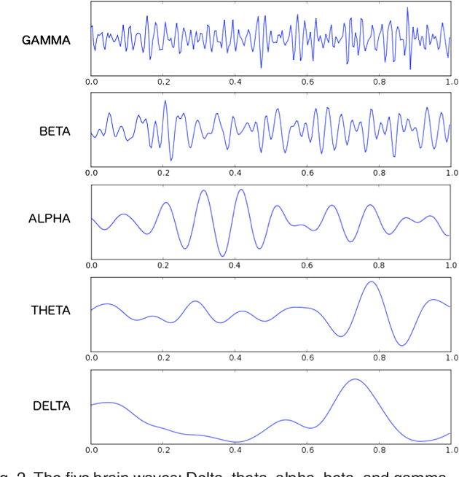V Waves: V waves occur in the parietal regions on both sides and primarily occur during sleep. They can appear after disruptions in sleep and, similar to K-Complex waves, may appear during brief semi-arousals. V waves are easily recognizable [16].

**Figure 3:** Different frequency bands of an EEG signal

* Lambda Waves: Lambda waves are sharp, triangular transients that appear over the occipital region of a person who is walking and visually exploring. They occur when the eyes gaze at a blank surface. Lambda waves also appear when reading or watching television. They are a normal waveform and can appear as single waves, short runs, or long runs [16].
* Spike Waves: Spike waves are commonly seen in people of all ages, with a preference for children. They are large-amplitude slow waves, typically in delta waves, with a frequency of 3 Hz and originate from the thalamic structures. Spike waves may appear synchronously and systematically in generalized epilepsy or locally in the parietal region. They are more likely to occur in cases of brain injury and Lennox-Gastaut syndrome [16].
* Sleep Spindles: Spindles, also known as sigma activity, are waves that range from 11 to 15 Hz and occupy the upper level of alpha or lower level of beta. They occur mostly during sleep stages, particularly stage 2, and are primarily seen in the parasagittal regions [16].

Out of these brain categories, the major categories are Delta, Theta, Alpha, Beta and Gamma. Mainly these categories are studied and the experiments are carried out using them. The Table 1 shows the frequency range, behavioral state of brain and location of brain where these bands lie.

| **Type** | **Frequency (Hz)** | **Behavioral /Psychological State** | **Location** |
| --- | --- | --- | --- |
| Delta | 0-4 | Deep rest, dreamless sleep | Frontally in adults, posteriorly in children |
| Theta | 4-8 | Deeply relaxed | Thalamic region |
| Alpha | 8-13 | Day dream, calm | Posterior regions |
| Beta | 13-30 | Alert, active thinking, anxiety, panic attack, focus, concentration | Frontal and Parietal |
| Gamma | 30-100 | combination of two senses | Somatosensory cortex |

**Table 1:** Brainwave frequencies with their characteristics

For instance, the occipital and central regions of the cortex have higher levels of the mu-waves. It has a connection to motor control functions among other things. This study will frequently describe the signal energy that is concentrated in the mu-waves as a result. Electrodes are placed on the user's scalp to gather the EEG signals. But as was mentioned, the location of each sensor is crucial for the processing of the signals that are afterwards received. Therefore, a system known as 10-20 is frequently employed for EEG data gathering in order to position the electrodes across important and pre-defined areas of the brain [10]. The EEG electrodes' location in relation to the user's head's size is indicated by the 10-20 system. The arrangement of the scalp electrodes in accordance with the 10-20 method is shown in Figure 4. Each electrode is identified by the area of the cortex that it is measuring (example: O - Occipital region) [13].

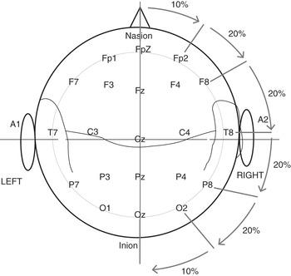The right hemisphere of the brain is represented by electrodes with even numbers, whereas the left hemisphere is represented by electrodes with odd numbers. The percentages represent how far apart the Nasion (top section of the nose) and Inion are from one another (back of the head). The 10-20 system, which was chosen as the standard in this investigation, is a crucial one for EEG data collecting [13].

**Figure 4:** 10-20 positioning system: the electrodes are separated between distances of 10 and 20 percent of the dimensions of the head.

### **Artifacts**

Although non-invasive techniques make it easier to gather EEG signals, the acquired signals' overall quality is severely constrained by the fact that the signals are read very far from their sources. The information connected to cerebral activities is significantly worsened and suppressed by the presence of signals not coming from the brain, sometimes known as artifacts [17]. These undesirable signals might originate from a variety of places, including [2]:

* Muscles around the head produce electrical activity, which is measured by electromyography (EMG) (neck, face, etc.)
* Electrooculography (EOG) is a measurement of eye movements, which may affect the EEG signals in the form of artifacts.
* Noise produced at 50 Hz by the power supply cables. It is a significant source of noise during EEG acquisitions. Filters are typically included in EEG headset to effectively block this type of noise. The electrical connection between skin and electrodes is weak, and incorrect connection of electrodes leads to high-impedance connections which worsen the 50Hz contamination.
* Electrocardiography (ECG): In some cases, the electrical activity of the heart might affect the findings from the EEG.

Standard operating procedures used during the acquisition sessions or the application of sophisticated filtering algorithms limit the presence of artifacts in EEG signals. However, it is frequently impossible to completely eliminate such noise sources, hence artifacts are always present in any EEG output [13].

### **EEG Signal Pre-Processing**

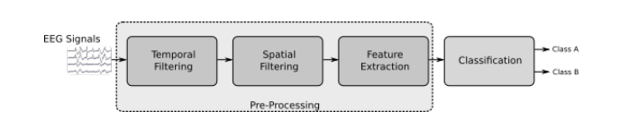While the EEG headset plays a vital role in the overall quality of the BCI system implementation, the stage that follows, responsible for digital processing of the acquired signal, is also important in enhancing the system's accuracy and usability [18]. In this section, the signal processing mechanisms applied to the incoming signal from the brain are discussed. In Figure 5, a block diagram of the signal processing stage in a BCI system is presented. Typically, the signal processing is split into two sub-modules: pre-processing and classification. The former is responsible for eliminating noise and mathematically transforming the signal to enhance specific features [19]. Additionally, in the preprocessing stage, specific features are extracted from the filtered signal to be used as input by the classifier [11]. The unprocessed EEG signal holds the recorded electrical potential for each channel over time, which includes brain activity, noise, and any unwanted signals such as artifacts [17], the aim of the preprocessing step is to apply mathematical operations on the input signal to isolate or emphasize only the relevant information.

**Figure 5:** A block diagram of signal processing stage in a BCI

The preprocessing stage can be divided into smaller units that handle the transformation of signals in various ways to eliminate different types of noise or artifacts. Temporal filtering, which processes EEG signals in the time domain, and spatial filtering, which improves the representation of neural activity and removes interfering signals that may affect EEG data quality, are two significant filtering methods widely utilized in BCI systems [13].

### **Feature Extraction**

After applying temporal and spatial filtering techniques, it is important to choose the right set of features taking into account the characteristics of the signal to be classified and, more importantly, the mechanisms used for classification, which will be presented next. Some common features that could be extracted from motor imagery EEG data include:

* Power Spectral Density (PSD): PSD is a measure of the power of the EEG signal at different frequencies. It can be used to identify changes in specific frequency bands, such as the alpha, beta, theta, and gamma bands.
* Event-related potentials (ERPs): ERPs are specific patterns of brain activity that occur in response to a specific event or stimulus. They can be used to identify changes in the EEG signal that are specific to different imagined movements.
* Time-frequency analysis: Time-frequency analysis is used to examine how different frequency bands of the EEG signal vary over time. This can be useful in identifying changes in the EEG signal that are specific to different imagined movements.
  + 1. **Different Paradigms of BCIs**

EEG signals often cover the entire range of brain activity throughout the acquisition sessions. It is impossible to examine all brain reactions at once, especially for BCI applications, hence it is more intriguing to investigate individual brain responses to particular stimuli or even to particular subject behaviors. Numerous responses, including P300 responses [20], steady-state visual evoked potentials (SSVEPs) [21, 22], mu-waves [23], and others, have been investigated in BCI systems for this purpose. These reactions are all appropriate for various BCI applications. EEG recording with various paradigms, including:

* SSVEP (Steady-State Visual Evoked Potential): Involves presenting visual stimuli to the participant and recording EEG signals to study the brain's response to the stimuli [24-27].
* Motor Imagery: Involves asking the participant to imagine performing a specific motor imagery task (such as moving their hand) and recording EEG signals to study the brain's activity during the imagined movement [22, 28, 29].
* Visual Imagery: Involves asking the participant to imagine visual scenes, objects, landscapes, or faces and recording EEG signals to study the brain's activity during the imagination task [30-33].
* Auditory Evoked Potentials: Involves presenting auditory stimuli to the participant and recording EEG signals to study the brain's response to the stimuli [34-36].
* P300: Involves presenting a sequence of visual or auditory stimuli to the participant and recording EEG signals to study the brain's response to target stimuli [37-40].
* Resting-State EEG: Involves recording EEG signals while the participant is at rest, without performing any specific task. This can be used to study the brain's activity in the absence of any specific cognitive demands [41-43].
* Event-related potentials (ERPs): This method involves recording EEG activity in response to specific events or stimuli, such as visual, auditory, or somatosensory stimuli. ERPs provide a way to study the temporal dynamics of brain activity and can be used to investigate cognitive processes such as attention, memory, and decision-making [44-48].

These techniques can be used to study the brain's electrical activity while it is processing information and performing specific mental tasks. The recorded EEG data can be analyzed to identify specific patterns of brain activity that are associated with these tasks, providing insight into the underlying neural mechanisms and helping to develop applications such as brain-computer interfaces or brain-controlled prosthetics. For our project, we had used the Motor Imaginary (MI) technique.

## **Drone Navigation**

Drone navigation refers to the process of guiding a drone from one location to another in a safe and efficient manner. Effective navigation is critical for the successful operation of drones and is achieved through a combination of sensors, algorithms, and communication systems.

* + 1. **Importance of Drone Navigation**

Drone navigation is important for a number of reasons. Firstly, it ensures the safety of the drone and its surroundings, as accurate navigation is necessary to avoid collisions and other hazards. Secondly, effective navigation is essential for the successful completion of drone missions, whether it be for aerial photography, delivery services, search and rescue, or military operations. Thirdly, efficient navigation can impact the cost-effectiveness and sustainability of drone operations, as accurate navigation can reduce fuel consumption and minimize the need for additional flight time.

* + 1. **Applications of Drone Navigation**

Drone navigation has a wide range of applications, including:

* Aerial Photography: Drones equipped with high-resolution cameras are used for aerial photography and videography, providing unique perspectives for capturing images and video from the sky.
* Delivery Services: Drones are increasingly being used for delivery services, allowing for fast and efficient delivery of goods and packages, particularly in hard-to-reach or remote locations.
* Search and Rescue: Drones equipped with thermal cameras, loudspeakers, and other sensors can be used for search and rescue operations, helping to locate missing persons and provide assistance in disaster-stricken areas.
* Military Operations: Drones are used by the military for a variety of missions, including reconnaissance, surveillance, and target acquisition.
  + 1. **Traditional Drone Navigation Methods**

Following are some of the Traditional Drone Navigation Methods:

* GPS: GPS (Global Positioning System) is a widely used traditional method for drone navigation. GPS uses a network of satellites to determine the position of a drone in real-time. The drone receives signals from multiple satellites and uses this information to calculate its position, velocity, and altitude. GPS is highly accurate, but its use is limited in areas with poor satellite coverage or when the signal is obstructed, such as when flying in urban areas with tall buildings.
* Ultrasonic Sensors: Ultrasonic sensors use sound waves to measure the altitude and proximity of the drone to objects in its surroundings. The sensors emit high-frequency sound waves, and the time it takes for the waves to bounce back to the sensor is used to calculate the distance to the object. Ultrasonic sensors are often used in conjunction with other sensors, such as cameras or infrared sensors, to provide a more comprehensive view of the drone's environment.
* Computer Vision: Computer vision is a technology that uses cameras and image recognition algorithms to provide real-time navigation information. This technology enables the drone to identify and track objects in its environment and use this information to make decisions about its navigation path. Computer vision can be used for obstacle avoidance, target tracking, and other applications that require the drone to recognize and respond to its surroundings.
  + 1. **Limitations and Challenges of Traditional Drone Navigation Methods**

Following are some of the challenges and limitations of traditional Drone navigation methods:

* GPS: GPS-based navigation is highly accurate, but its use is limited in areas with poor satellite coverage, such as when flying in urban areas with tall buildings. GPS signals can also be disrupted by natural phenomena such as solar flares or interference from other sources. Additionally, GPS does not provide any information about the drone's environment, making it difficult to avoid obstacles or navigate in areas with limited visibility.
* Ultrasonic Sensors: Ultrasonic sensors are relatively inexpensive and easy to integrate into drone designs, but they have limited range and can be affected by environmental factors such as wind and temperature changes. Ultrasonic sensors are also susceptible to interference from other sources of sound, such as other ultrasonic sensors or ambient noise.
* Computer Vision: Computer vision-based navigation is capable of providing rich information about the drone's environment, but it requires powerful processors and cameras, which can increase the size, weight, and cost of the drone. Additionally, computer vision algorithms are computationally intensive, which can limit the amount of data that can be processed in real-time.

These limitations and challenges demonstrate the need for improved methods for drone navigation. By addressing these issues, it may be possible to develop navigation systems that are more reliable, accurate, and efficient, enabling drones to operate in a wider range of environments and applications.

A drone, which is capable of moving in three dimensions and has highly agile flight capabilities, poses various challenges related to its movement dynamics, to put it simply [49]. Therefore, it is possible to assess the limitations in terms of dynamics and ease of use posed by these systems by constructing a BCI system to handle such targeted applications. The control of simpler devices will become more stable and trustworthy as BCI technology advances and can manage more complex applications, such as a drone [13].

## **Problem Identification**

The objective of this project is to complete the development of a BCI system that utilizes mu-waves from the motor cortex for controlling a drone in six directions (up, down, left, right, forward and backward) through actual movements. The design challenges encountered will be analyzed and documented in detail. The system will utilize widely accepted algorithms, for filtering and classifying EEG patterns, which are commonly used in BCI. The implementation will be based on the low-cost and open-source EEG headset OpenBCI, with the goal of resolving the mentioned issues.

# **PROPOSED APPROACH**

This section explains the proposed approach of our BCI system that utilizes such signals. These systems are referred to as brain-computer interfaces (BCI) as they translate the information contained in neural signals into useful commands that are sent to an application, effectively creating an interface between the brain and external devices [2]. In Figure 1 a functional diagram of a typical BCI system is depicted. The first stage involves the acquisition of brain signals, where the analog data produced by brain activity is digitized and sent to a digital processing system. The signal is then processed using filtering techniques to reduce noise and improve specific attributes. During the processing stage, these attributes, often referred to as features, are classified based on predefined patterns. After preprocessing stage, the signal is sent to the classification module. Finally, the predicted label is transformed into command that is sent to a target device, drone in our case, to fly in a specific direction.

## **Dataset Discussion**

### **Motor Imagery in EEG Signals**

In this work, we have used motor imagery approach for drone navigation using the human brain to control the movement of a drone. This method involves the use of EEG (electroencephalography) technology to record and interpret the electrical activity of the brain. The user performs a specific movement, such as moving both hands, both feet and none, which then translated into control commands for the drone to execute as left, right and pause respectively. This approach has the potential to revolutionize drone navigation as it provides a new way to interact with these devices, making them more accessible and easier to control. However, it is still a relatively new field and more research is needed to fully understand its capabilities and limitations.

The alpha-band (8–12 Hz) is the range of frequencies covered by the mu-wave, an oscillating signal [11]. Since the brain's motor activity is intimately correlated with the mu-waves, they can be detected primarily over the motor cortex [3].

### **EEG Signal Acquisition**

The data acquisition process involves the subject sitting in a relaxed position on a chair with their hands in a resting position and feet touching the floor. The process takes place in an environment without electronic devices near the subject to minimize noise from the 50Hz power line frequency. This is important because the components of the acquisition system are not well isolated. During the acquisition, the subject was shown a motor action on a screen that they must perform like moving hands or feet or none (doing no action). The recording lasts approximately 8 seconds, with the actual recording starting after 6 seconds and lasting for 1 second to capture the most stable samples possible. The subject must perform multiple sessions of the acquisition process to help the network generalize effectively, as even minor movements or misalignment of an electrode can produce different data. Each session records a total of 50 samples. The data we have recorded was only comprised of one subject.

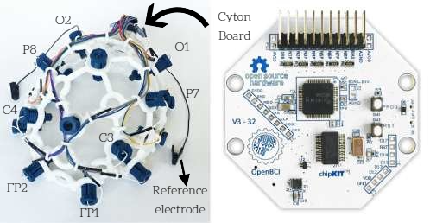One of the primary considerations when working with BCI systems is ensuring that the signal acquisition stage is reliable and well executed [10]. A successful signal acquisition session produces high-quality signals with an acceptable number of artifacts. In BCI systems, the EEG signal is digitally converted by an EEG headset, which collects the signals from the electrodes, performs basic analog filtering and amplification, and sends the digitized signals to a digital processing system. EEG headsets are available in the market with varying specifications, such as the number of input electrodes, analog-to-digital resolution (in bits), frequency bandwidth, and more. Because these devices require precise electronic components and strong safety circuitry, they tend to be more expensive compared to conventional analog amplifiers [50]. This work will explore the utilization of a low-cost and open-source EEG headset called OpenBCI Ultra cortex Mark IV headset as shown in Figure 6.

**Figure 6:** OpenBCI Ultracortex Mark IV headset with Cyton Board

### **OpenBCI Headset**

The Ultra cortex is an open-source, 3D-printable headset designed to work with the OpenBCI system. It is a tool for recording research-grade brain activity (EEG signals). EEG signals were acquired using eight Ag/AgCl electrodes following the 10-20 international systems. The Ultra cortex Mark IV Headset (Cyton board is mounted on the head cap) has eight channels namely Fp1, Fp2, C3, C4, P7, P8, O1 and O2 and 2 reference electrodes as shown in Figure 6. These two ear clip electrodes (reference electrodes), which come with the headset kit, serve as the reference and bias (ground with common-mode noise rejection) for the EEG system. The ground and reference channels are FCz and FPz positions, respectively.

### **USB Dongle**

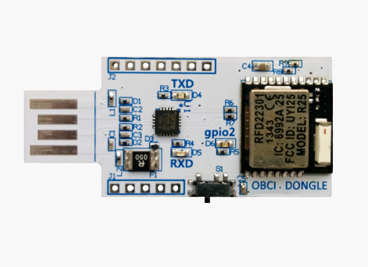After the headset, USB Dongle is another important component that helps visualizing, analyzing and storing EEG signals by capturing data of electrodes from Cyton board and transferring it to the computer. The OpenBCI USB Dongle is a small device as shown in Figure 7 that is used in conjunction with OpenBCI EEG (electroencephalography) systems to wirelessly connect EEG electrodes to a computer or other device. The OpenBCI Dongle uses Bluetooth Low Energy (BLE) technology to provide a low-latency, high-bandwidth connection between the EEG electrodes and the computer or device, allowing for real-time data transfer

**Figure 7:** USB Dongle

and analysis. The OpenBCI Dongle is designed to be easy to use and provides a convenient and flexible way to connect EEG electrodes to a computer or device for a wide range of 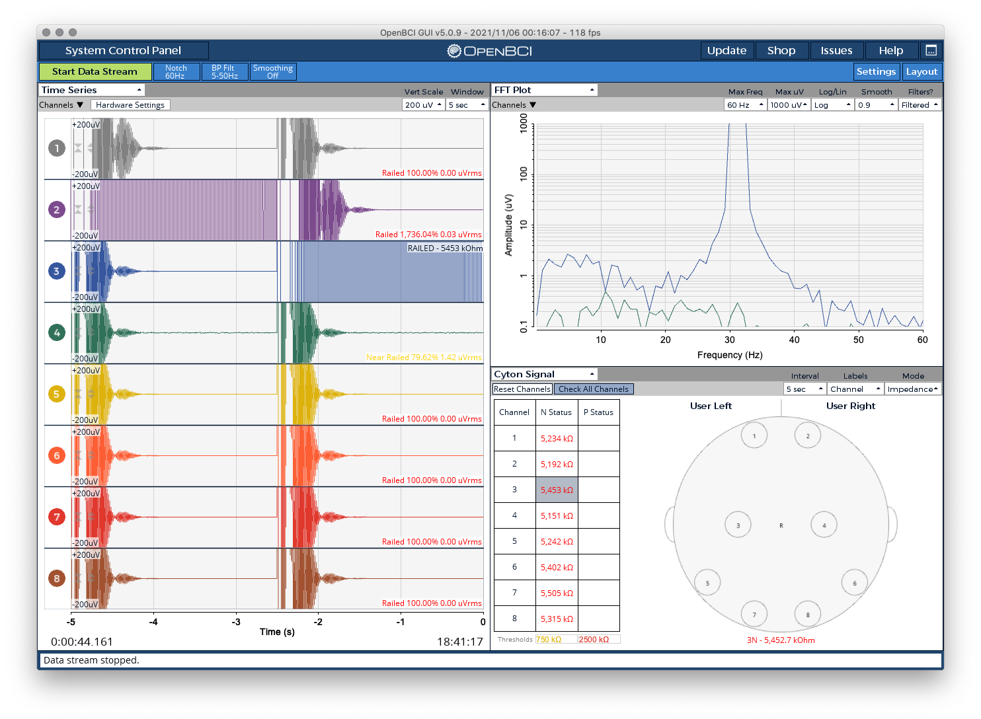applications, including research, medical applications, and DIY (Do It Yourself) projects.

**Figure 8:** OpenBCI GUI

### **OpenBCI GUI**

After inserting the OpenBCI USB dongle to your laptop or PC, OpenBCI GUI is the next important part to deal with. OpenBCI GUI refers to the graphical user interface software developed by OpenBCI for use with their brain-computer interface hardware devices. The OpenBCI GUI software allows users to visualize, analyze, and interact with EEG data in real-time, making it easier to perform experiments, evaluate data, and develop new applications. It provides features such as filtering, gain adjustment, and artifact removal, among others that are essential for reliable EEG data acquisition. The signals captured by the USB dongle can be easily visualized in OpenBCI GUI channel wise as shown in Figure 8. This software can also help recording EEG signals and this software also provides a way to get these signals into other code using networking.

## **Data Preprocessing**

The dataset that was obtained using the hardware described in Section 2.1.3 and following the procedure outlined in Section 2.1.2 on the previous page consists of 250 samples that are equally divided into six categories. These categories correspond to six distinct motor imagery activities, namely: moving the feet, moving the head, eye-blinking, jerking the hand, clinching the hand and chewing the teeth.

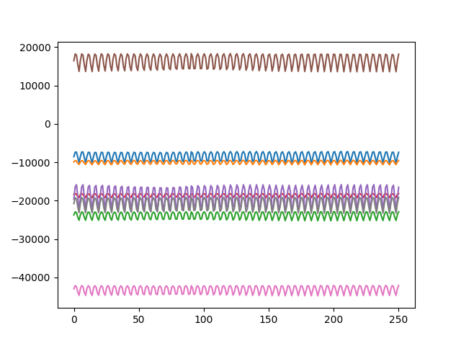The data acquisition protocol outlined above captures each sample as an EEG signal stored in a matrix. Each row of the matrix represents a different electrode, and since the Cyton Board has a sample rate of 250Hz and a one-second acquisition time, each channel in a sample will have 250 timestamps. As a result, each sample is represented as an 8x250 matrix. The data is not processed during acquisition to preserve the option of adjusting parameters such as low-pass and high-pass frequency filters later on. Figure 9 illustrates a sample prior to any processing. It can be observed that the board stores each channel with a different range.

**Figure 9:** Raw EEG Data

Following the initial important step, the next step in manipulating the data is to implement a notch filter to eliminate either the 50Hz or 60Hz frequency, depending on the local power grid system. The preferred method is to utilize a Butterworth band-stop filter from BrainFlow.

Finally, we conducted band-pass filtering. Through grid searches, we determined that 2Hz and 65Hz were the optimal thresholds. This filtering process was accomplished using a Butterworth band-pass filter from the BrainFlow library.

Before the EEG data can be analyzed, it is important to standardize the dataset so that all channels have the same scale. This standardization process is performed channel by channel, so that each channel has a mean of zero and a standard deviation of one. This ensures that each channel is not influenced by other channels in the same sample or other samples in the dataset. The data after standardization process is shown in Figure 10, where the data is 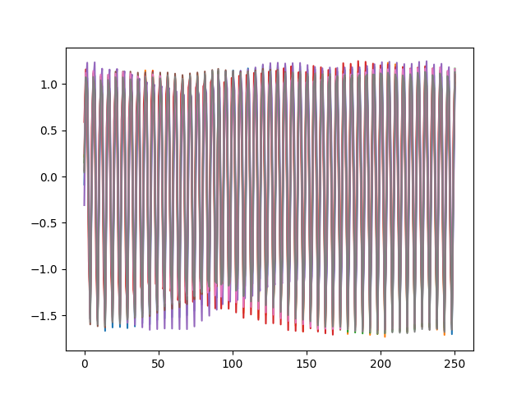displayed after being standardized on a channel-by-channel basis.

**Figure 10:** EEG data after Standardization

## **Model Training and Fine Tuning**

The system can be divided into two different operation modes: model training and online operation. The first one is dedicated to the training and testing of models on the available dataset and online mode then uses these models to process the EEG data in real time and pass it to the drone.

**Figure 11:** EEGNet Architecture

In our experiment, EEGNet [51] was utilized as the end-to-end convolutional neural network. This compact CNN architecture is designed for EEG-based brain-computer interfaces and can be applied to various BCI paradigms, even with limited training data. As shown in Figure 11, the network is composed of 4 blocks: a Conv2D block, followed by a DepthwiseConv2D block, a SeparableConv2D block, and a final block for classification.

The Conv2D block uses F1 2D convolutional filters of size (1,125), where the filter length is half the data's sampling rate (250Hz in this case). The output is F1 feature maps that display the EEG signal across different band-pass frequencies. By having the temporal kernel length set to half the sampling rate, it enables capturing frequency information of 2Hz and higher. This block performs a temporal convolution that only gathers information along the time dimension, as depicted in Figure 12. After the temporal convolution, Batch Normalization [52] is applied to the feature map dimension.

The DepthwiseConv2D block applies a Depthwise Convolution with a kernel size of (Channel, 1) to learn a spatial filter. In computer vision applications for CNNs, the main advantage of a depthwise convolution is that it reduces the number of trainable parameters by not being fully connected to all previous feature as shown in Figure 11. In EEG-specific applications, this operation enables the direct learning of spatial filters for each temporal filter, resulting in the efficient extraction of frequency-specific spatial filters (as depicted in Figure 12). The number of spatial filters learned for each feature map is controlled by the depth parameter D. The weights of 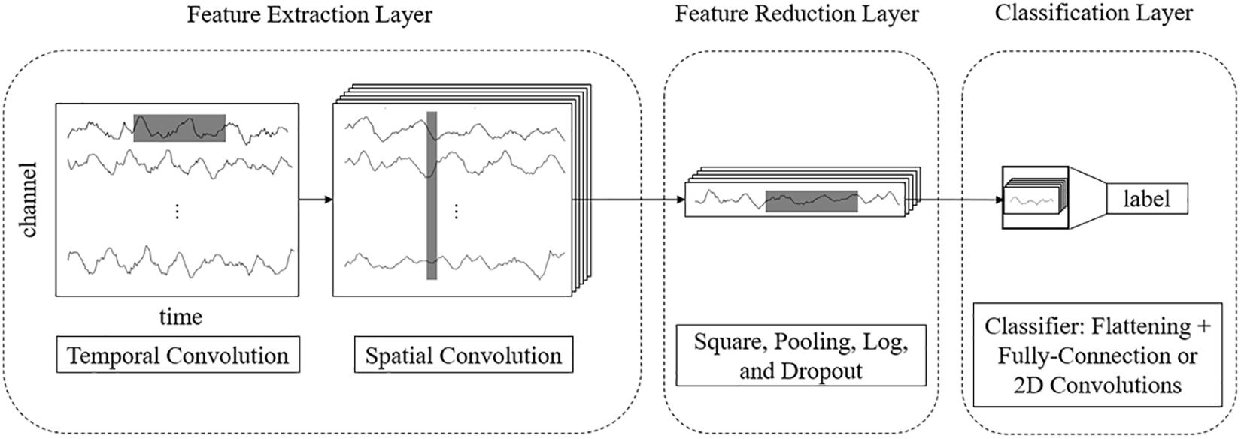each spatial filter are also regularized using a maximum norm constraint of 1.

**Figure 12:** Feature Extraction Layer

After the depth wise convolution, a Batch Normalization layer is applied along the feature map dimension and followed by an exponential linear unit (ELU) non-linearity. To reduce the signal’s sampling rate and further regularize the model, an average pooling layer with a kernel size of (1,4) and a dropout layer with a dropout probability of 0.5 are applied. The SeparableConv2D block uses a Separable Convolution, which consists of a Depthwise Convolution (in this case, with a kernel size of (1,16)) followed by F2 (1,1) point-wise convolution. This type of convolution reduces the number of parameters to fit and decouples the relationships within and across feature maps by first learning a kernel that summarizes each feature map individually, and then optimally merging the outputs. When used for EEG-specific applications, this operation separates the learning of how to summarize individual feature maps in time (the depthwise convolution) from how to optimally combine the feature maps (the pointwise convolutions). This is particularly useful for EEG signals, as different feature maps may represent data at different time-scales of information. After the separable convolution, Batch Normalization, ELU activation function, and an average pooling layer of size (1,8) are applied. In the classification block, the features are directly passed to a SoftMax classification with N units, where N is the number of classes in the data. A dense layer for feature aggregation is omitted to reduce the number of free parameters in the model.

As deep learning framework we used Keras [53] with TensorFlow backend. Due to the lack of data, in order to have robust results, a 5-fold cross validation is performed, during each step of the process 70% of the data is used as training set (210 samples), 20% as validation set (60 samples) and 10% as test set (30 samples). The splitting process takes into account the label of the samples, ensuring that each set is perfectly balanced among the six classes. The model which has been tested at each k-fold step is the one with the smaller loss on the validation set. As final result of the 5-fold process, we take as a result the average of accuracy among the ten test set results. We then repeated the above-mentioned pipeline for five times and we took as results the average. The model has been trained for a maximum of 10k epochs, Adam optimizer with a learning rate equal to 5e-5 was used and batch size is set to 32.

## **Online Operation**

In Online operation the trained model was tested in real time after acquiring the EEG signals from Open BCI headset and results were shown in AirSim virtual drone simulator. At first the hardware was setup that consisted an OpenBCI headset, that is used to receive signals from the subject brain and transmit them to the virtual drone. The OpenBCI headset was connected to a laptop. Next software was setup, drone simulator and loading the trained model. The model was configured to receive signals from the BCI device and use them to control the movement of the drone. The subject was instructed to relax and clear their mind before the test and perform same actions that they performed while dataset acquisition. Finally, after carrying out few experiments live testing showed that the BCI-based drone navigation model was able to accurately control the movement of the drone in response to the subject’s movements. If subject perform the eye-blink movement, virtual drone move left and if subject perform feet movement virtual drone move right, if subject moves his/her head, the virtual drone moves upward, if the subject perform clenching, the virtual drone will move forward, if the subject perform jerking of hand, the virtual drone will move backward and if the subject perform chewing, the virtual drone will move down. The drone was able to perform the desired movements smoothly and effectively.

## **Drone Navigation on Simulator**

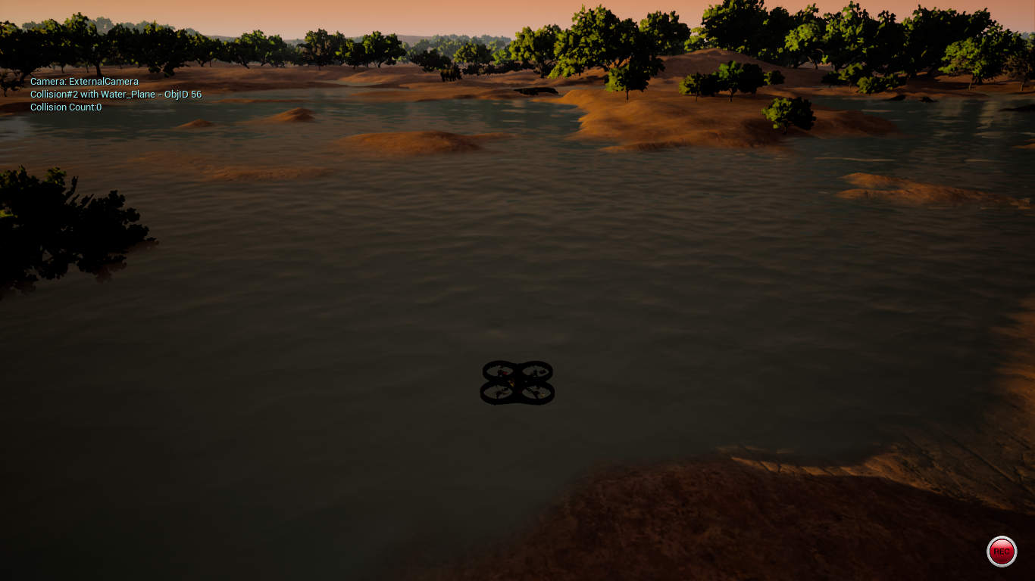For the purpose of simulation, we had used AirSim open source drone simulator. It is a free to use software by Microsoft that with the help of unreal-engine, stimulate the drone in any environment. The software provide the integration with the python using the airsim python library. First you have to install the library, import it in python and start the connection with the software. It is an easy to use and user-friendly software. We had used this software to show the simulation of drone. You can see the interface of the software in the Figure 13.

**Figure 13:** AirSim Drone Simulator

# **EVALUATION TESTBED**

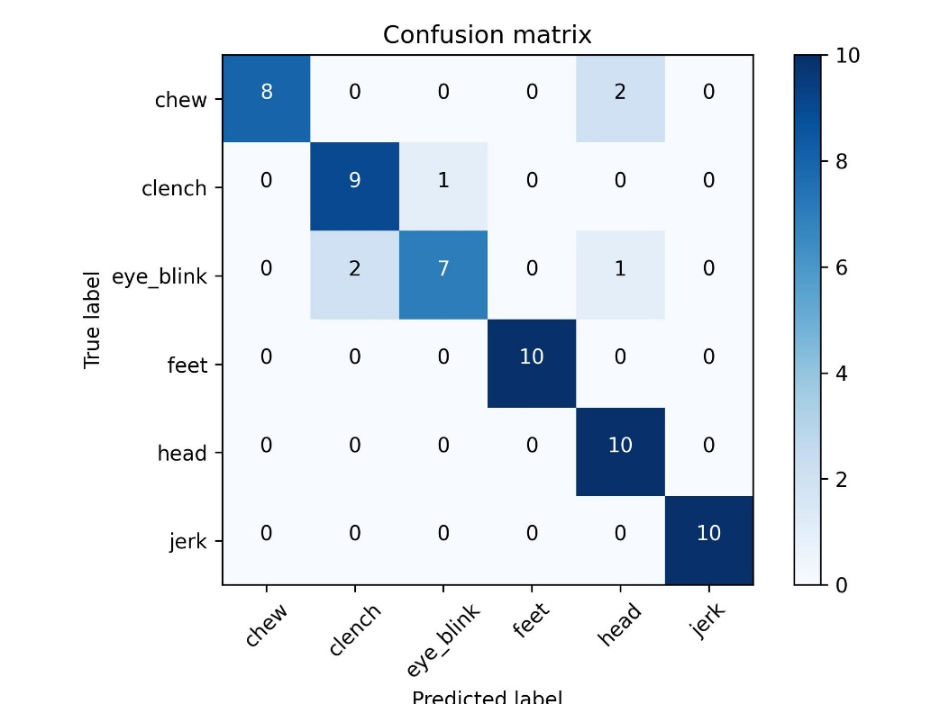To evaluate the performance of the underlying model, we will use a number of metrics, including accuracy. These metrics will be calculated for each class, as well as for the overall model performance. We had used confusion matrix to visualize the model's performance. It is a table used to define the performance of a classification algorithm. Each column of the matrix represents the instances in a predicted class while each row represents the instances in an actual class. The diagonal elements represent the number of points for which the predicted label is equal to the true label, while off-diagonal elements are those that are mislabeled by the classifier; confusion matrix of our model is presented below in Figure 14.

**Figure 14:** Confusion Matrix

# **RESULTS AND DISCUSSION**

The performance of our BCI system is evaluated by analyzing the underlying model performance. The model is trained and tested on the EEG dataset and its performance is measured in terms of accuracy. The model gave accuracy of 89%. We also evaluated the model's performance in terms of its ability to classify the different performed movements with respect to the six different directions. In addition, we will evaluate the system's performance in terms of its ability to control the Tello EDU drone in real-time in future. The results of these evaluations are discussed in the above chapter and provide insights into the strengths and limitations of our system. We had also mentioned the possible improvements that can be made to enhance the system's performance in the future in the next section.

# **LIMITATIONS AND FUTURE WORK**

## **Limitations**

Following are the limitations of our project Drone Navigation using BCI:

* There are only six directions in which the drone could navigate, no other actions, or operations of the drone will be supported by our project.
* EEGNet model accuracy is still not up to the mark.
* Our project is not a compact hardware device as a sellable product.
* Our work is based on subject-specific trained model.

## **Future Work**

There can be the following potential future work in our project:

* Other drone actions like flip roll, or operations can be added to control by the brain signals in the project as a future work.
* EEGNet model accuracy can be improved as a future work.
* Our project can be modified into a complete sellable product by making the easily manageable and user-friendly headset connected with the mobile app discarding the need of a PC.
* Subject-specific trained model can be replaced by non-subject-specific model.

# **REASONS FOR FAILURE *(If Any)***

We have not yet integrated the model with a real drone. Currently, we have only been able to simulate the six commands using AirSim virtual drone simulator. However, we plan to do so in the near future for the research purpose.

# **PROJECT MANAGEMENT UTILITY**

Throughout the course of our FYP, we found the role of our Project Manager to be incredibly valuable. Our PM demonstrated honesty, helpfulness, cooperation, and timeliness in their management of the project, which greatly contributed to its success. Some specific ways in which we found the PM to be effective include:

Honesty: Our PM was always transparent with us regarding the project's progress and any issues that arose, which helped us to stay informed and make informed decisions.

Helpfulness: Our PM provided guidance and support when needed, gave valuable feedback on our work, and helped us to stay on track.

Cooperation: Our PM was open to working with us as a team, and was receptive to our ideas and suggestions, which made us feel that our input was valued.

Timeliness: Our PM was always punctual and timely in their management of the project, setting clear deadlines and helping us to stay on schedule.

In conclusion, the PM played a crucial role in the success of our FYP. The honesty, helpfulness, cooperation, and timeliness of the PM made the overall project management experience efficient and effective.

# **REFERENCES**

1. Veena, N. and N. Anitha, *A review of non-invasive BCI devices.* Int. J. Biomed. Eng. Technol, 2020. **34**(3): p. 205-233.

2. *J. Wolpaw and E. W. Wolpaw. Brain–Computer Interfaces: Principles and Practice. Oxford Scholarship, 1 edition, 2012.*

3. Marin, I., M.J.H. Al-Battbootti, and G. Nicolae. *Drone control based on mental commands and facial expressions*. in *2020 12th International Conference on Electronics, Computers and Artificial Intelligence (ECAI)*. 2020. IEEE.

4. Lin, J.-S. and Z.-Y. Jiang, *Implementing remote presence using quadcopter control by a non-invasive BCI device.* Computer Science and Information Technology, 2015. **3**(4): p. 122-126.

5. Chiuzbaian, A., J. Jakobsen, and S. Puthusserypady. *Mind controlled drone: An innovative multiclass SSVEP based brain computer interface*. in *2019 7th International Winter Conference on Brain-Computer Interface (BCI)*. 2019. IEEE.

6. Vishwanath, R.M., S. Kumaar, and S. Omkar, *A real-time control approach for unmanned aerial vehicles using brain-computer interface.* arXiv preprint arXiv:1809.00346, 2018.

7. Villegas, I.D., J.R. Camargo, and C.A.P. Ch, *Recognition and Characteristics EEG Signals for Flight Control of a Drone.* IFAC-PapersOnLine, 2021. **54**(4): p. 50-55.

8. Alshbatat, A.I.N., L. Dong, and P.J. Vial, *AirServer: A mind-controlled assistive quadrotor drone aided by an intelligent fuzzy PD controller.* Jordan Journal of Electrical Engineering, 2016. **2**(3): p. 181-198.

9. Rosca, S., et al. *Quadcopter control using a BCI*. in *IOP Conference Series: Materials Science and Engineering*. 2018. IOP Publishing.

10. *M. Teplan. Fundamentals of eeg measurements. In In: Measurement Science Review, Volume 2, Section, page 2002.*

11. *A. Bashashati, M. Fatourechi, R. K. Ward, and G. E. Birch. A survey of signal processing algorithms in brain–computer interfaces based on electrical brain signals. Journal of Neural Engineering, 4(2):R32, 2007.*

12.  *N. Brodu, F. Lotte, and A. Lecuyer. Comparative study of band-power extraction techniques for motor imagery classification. In Computational Intelligence, Cognitive Algorithms, Mind, and Brain (CCMB), 2011 IEEE Symposium on, pages 1–6. IEEE, April 2011.*

13. *Rafael Mendes Duarte. Low cost Brain Computer Interface system for AR.Drone Control. May, 2017.*

14. *D. Purves, G. J. Augustine, D. Fitzpatrick, L. C. Katz, A.-S. LaMantia, J. O. McNamara, and S. M. Williams. Neuroscience. Sinauer Associates, 2 edition, 2001.*

15. *B. Graimann, B. Z. Allison, and G. Pfurtscheller. BrainComputer Interfaces: Revolutionizing Human-Computer Interaction. Springer Publishing Company, Incorporated, 2013.*

16. *J Satheesh Kumar, P Bhuvaneswari. Analysis of Electroencephalography (EEG) Signals and Its Categorization — A Study. International Conference on Modeling, Optimization and Computing (ICMOC 2012) .*

17. *M. A. Khan, M. R. Islam, and M. K. I. Molla. Artifact suppression from electroencephalography signals using stationary subspace analysis. In 2016 19th International Conference on Computer and Information Technology (ICCIT), pages 252–256, Dec 2016.*

18. *F. Lotte. A tutorial on eeg signal processing techniques for mental state recognition in brain-computer interfaces. Springer, 2014.*

19. *Y. Wang, S. Gao, and X. Gao. Common spatial pattern method for channel selection in motor imagery based brain-computer interface. pages 5392–5395, Jan 2005.*

20.  *R. Fazel-Rezai, B. Z. Allison, C. Guger, E. W. Sellers, S. C. Kleih, and A. Kübler. P300 brain computer interface: current challenges and emerging trends. Frontiers in Neuroengineering, 5(14), 2012.*

21. *G. Edlinger and C. Guger. A hybrid brain-computer interface for improving the usability of a smart home control. pages 182–185, July 2012.*

22. *B. Choi and S. Jo. A low-cost eeg system-based hybrid braincomputer interface for humanoid robot navigation and recognition. PLoS ONE, 8(9):e74583, 09 2013.*

23. *C. Silva, R. Duarte, and A. Trofino. Feature extraction improvements using an lmi approach and riemannian geometry tools: An application to bci. In 2016 IEEE Conference on Control Applications (CCA), pages 966–971, Sept 2016.*

24. *Y. Zhang et al., “Frequency recognition in SSVEP-based BCI using multiset canonical correlation analysis,” Int. J. Neural Syst., vol. 24, no. 4, 2014, Art. no. 1450013.*

25. *Zhou, C., et al., D-Shaped Photonic Crystal Fiber Plasmon Sensors Based on Self-Reference Channel. IEEE Photonics Technology Letters, 2020. 32(10): p. 589-591.*

26. *Ravindran, K.K.G. and R.R. Machireddy. Exactly Periodic Spatial Filter for SSVEP Based BCIs. in 2018 International Conference on Cyberworlds (CW). 2018. IEEE.*

27. *Lin, Z., et al., Frequency recognition based on canonical correlation analysis for SSVEP-based BCIs. IEEE transactions on biomedical engineering, 2006. 53(12): p. 2610-2614.*

28. *J. Long, Y. Li, H. Wang, T. Yu, and J. Pan. Control of a simulated wheelchair based on a hybrid brain computer interface. In Engineering in Medicine and Biology Society (EMBC), 2012 Annual International Conference of the IEEE, pages 6727–6730, Aug 2012*

*.*

29. *D. Göhring, D. Latotzky, M. Wang, and R. Rojas. Semiautonomous car control using brain computer interfaces. In S. Lee, H. Cho, K.-J. Yoon, and J. Lee, editors, Intelligent Autonomous Systems 12, volume 194 of Advances in Intelligent Systems and Computing, pages 393–408. Springer Berlin Heidelberg, 2013.*

30. *Seo-Hyun Lee, Minji Lee, Ji-Hoon Jeong, and Seong-Whan Lee, Fellow. Towards an EEG-based Intuitive BCI Communication System Using Imagined Speech and Visual Imagery. IEEE*

*.*

31. Azmy, H. and N.M. Safri, *EEG based BCI using visual imagery task for robot control.* Jurnal Teknologi, 2013. **61**(2).

32. Sousa, T., et al., *Pure visual imagery as a potential approach to achieve three classes of control for implementation of BCI in non-motor disorders.* Journal of Neural Engineering, 2017. **14**(4): p. 046026.

33. Llorella, F.R., G. Patow, and J.M. Azorín, *Convolutional neural networks and genetic algorithm for visual imagery classification.* Physical and Engineering Sciences in Medicine, 2020. **43**(3): p. 973-983.

34. Punsawad, Y. and Y. Wongsawat. *On the enhancement of training session performance via attention for single-frequency/multi-commands based steady state auditory evoked potential BCI*. in *2012 Annual International Conference of the IEEE Engineering in Medicine and Biology Society*. 2012. IEEE.

35. Sun, K.-T., K.-L. Hsieh, and S.-Y. Lee, *Using Mental Shadowing Tasks to Improve the Sound-Evoked Potential of EEG in the Design of an Auditory Brain–Computer Interface.* Applied Sciences, 2023. **13**(2): p. 856.

36. Islam, M.N., et al., *Auditory Evoked Potential (AEP) Based Brain-Computer Interface (BCI) Technology: A Short Review.* Advances in Robotics, Automation and Data Analytics: Selected Papers from iCITES 2020, 2021: p. 272-284.

37. Li, M., et al., *The mindgomoku: An online P300 BCI game based on Bayesian deep learning.* Sensors, 2021. **21**(5): p. 1613.

38. Eidel, M. and A. Kübler, *Wheelchair control in a virtual environment by healthy participants using a P300-BCI based on tactile stimulation: training effects and usability.* Frontiers in Human Neuroscience, 2020. **14**: p. 265.

39. Akram, F., et al., *A Symbols Based BCI Paradigm for Intelligent Home Control Using P300 Event-Related Potentials.* Sensors, 2022. **22**(24): p. 10000.

40. Chen, X. and Z. Huang. *A P300 BCI calibration-free algorithm based on intersubject transfer and reinforcement learning*. in *2022 15th International Congress on Image and Signal Processing, BioMedical Engineering and Informatics (CISP-BMEI)*. 2022.

41. Babiloni, C., et al., *Measures of resting state EEG rhythms for clinical trials in Alzheimer's disease: Recommendations of an expert panel.* Alzheimer's & Dementia, 2021. **17**(9): p. 1528-1553.

42. Babiloni, C., et al., *International Federation of Clinical Neurophysiology (IFCN)–EEG research workgroup: Recommendations on frequency and topographic analysis of resting state EEG rhythms. Part 1: Applications in clinical research studies.* Clinical Neurophysiology, 2020. **131**(1): p. 285-307.

43. Siuly, S., et al., *A new framework for automatic detection of patients with mild cognitive impairment using resting-state EEG signals.* IEEE Transactions on Neural Systems and Rehabilitation Engineering, 2020. **28**(9): p. 1966-1976

.

44. Miao, Y., et al., *An ERP-based BCI with peripheral stimuli: validation with ALS patients.* Cognitive neurodynamics, 2020. **14**: p. 21-33.

45. Ni, Z., et al., *Improving cross-state and cross-subject visual ERP-based BCI with temporal modeling and adversarial training.* IEEE Transactions on Neural Systems and Rehabilitation Engineering, 2022. **30**: p. 369-379.

46. Gong, M., et al., *An idle state-detecting method based on transient visual evoked potentials for an asynchronous ERP-based BCI.* Journal of Neuroscience Methods, 2020. **337**: p. 108670.

47. Ogino, M., et al., *Analysis of prefrontal single-channel EEG data for portable auditory ERP-based brain–computer interfaces.* Frontiers in human neuroscience, 2019. **13**: p. 250.

48. Lahane, P., et al. *A review of recent trends in EEG based Brain-Computer Interface*. in *2019 International Conference on Computational Intelligence in Data Science (ICCIDS)*. 2019. IEEE.

49. *The Navigation and Control Technology Inside the AR.Drone Micro UAV, Milano, Italy, 2011.*

50. *J. Frey. Comparison of an open-hardware electroencephalography amplifier with medical grade device in brain-computer interface applications. CoRR, abs/1606.02438, 2016.*

51. Lawhern, V.J., et al., *EEGNet: a compact convolutional neural network for EEG-based brain–computer interfaces.* Journal of neural engineering, 2018. **15**(5): p. 056013.

52. Ioffe, S. and C. Szegedy. *Batch normalization: Accelerating deep network training by reducing internal covariate shift*. in *International conference on machine learning*. 2015. pmlr.

53. *Fran¸cois Chollet et al. Keras.* [*https://keras.io*](https://keras.io)*, 2015.*